All pictures shown below were captured on iPad, which were used for whole-class discussion when projected on Apple TV.

Initial Work on Comparing Right Triangle to Square
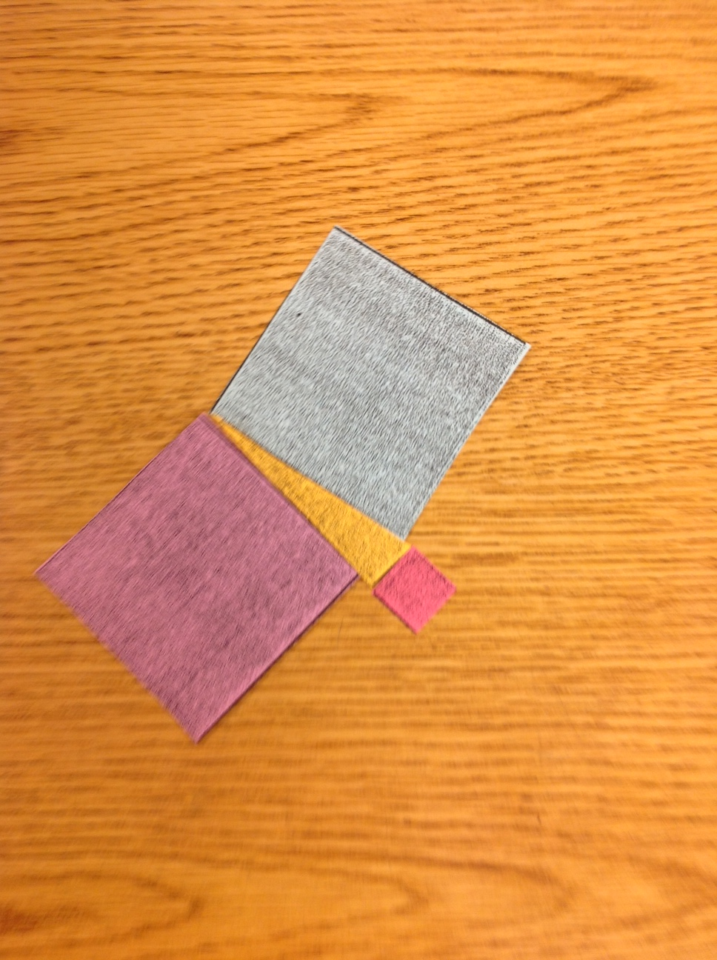

Explore Activity/Solving the Puzzle Talking Points

Different, but Equal Examples of Puzzles
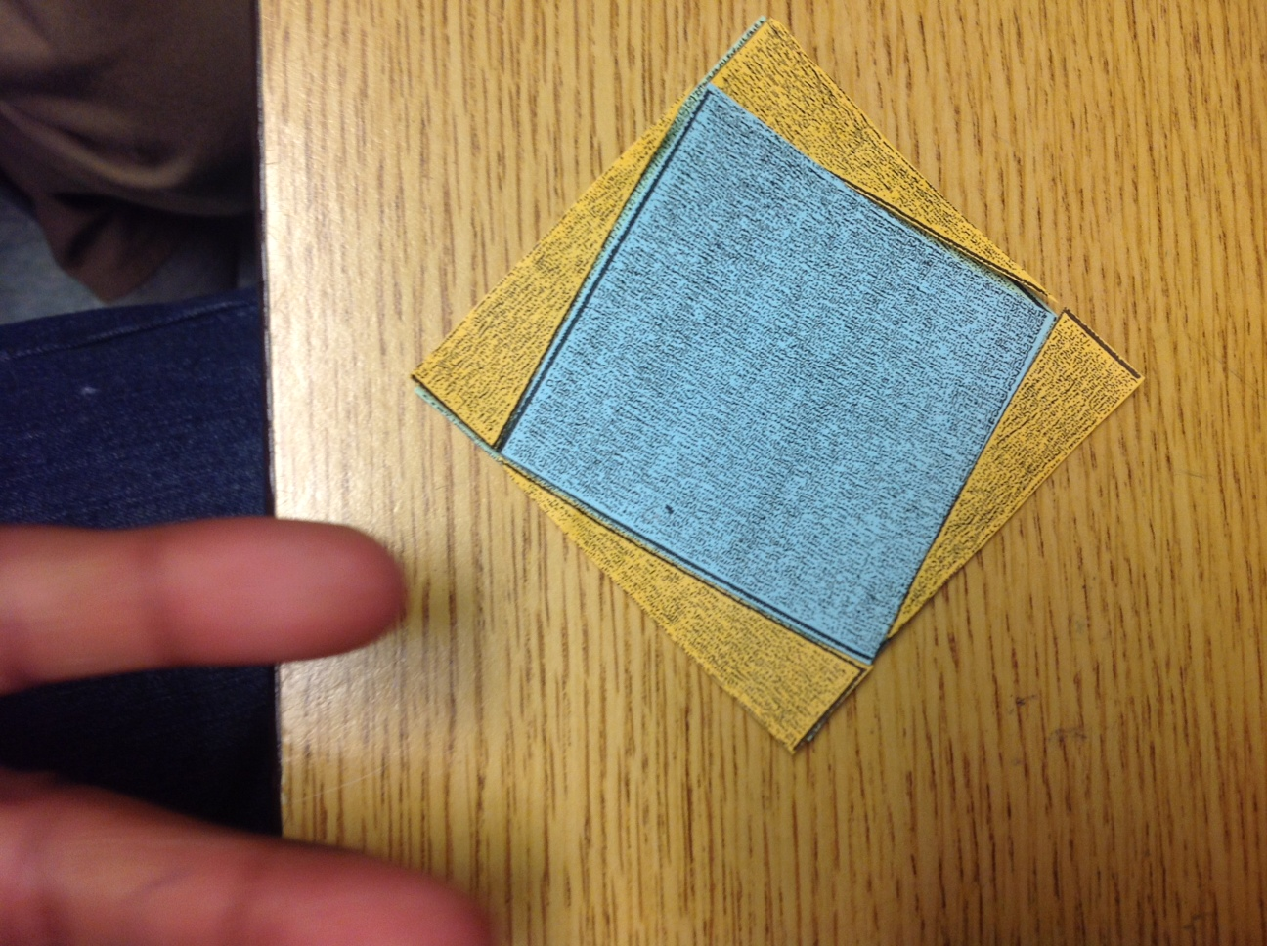
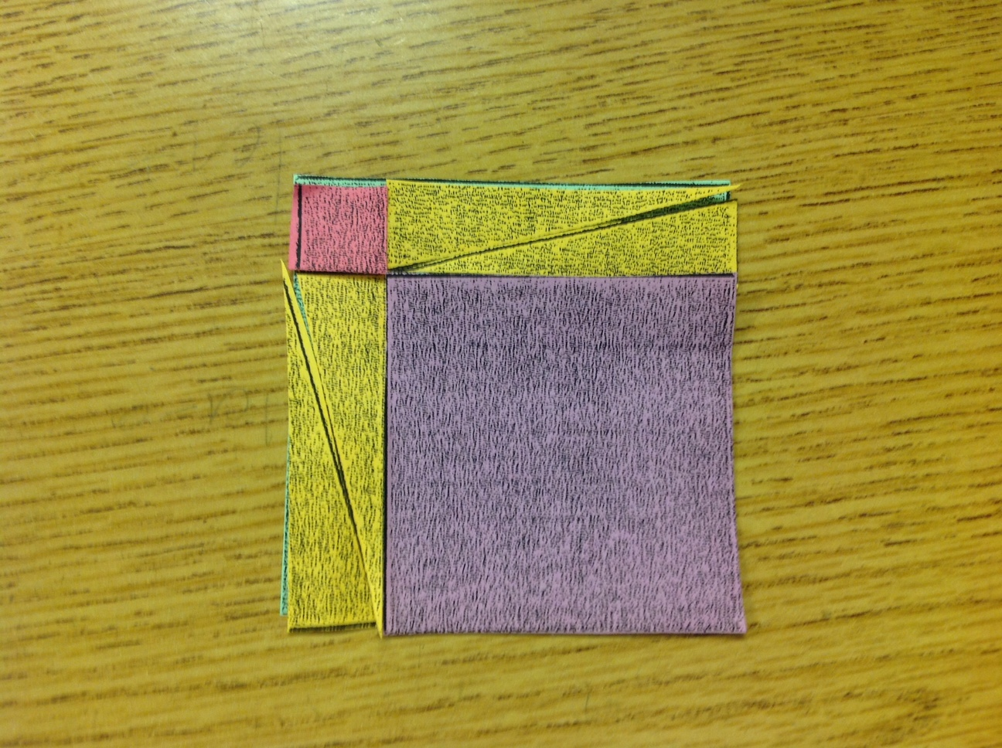

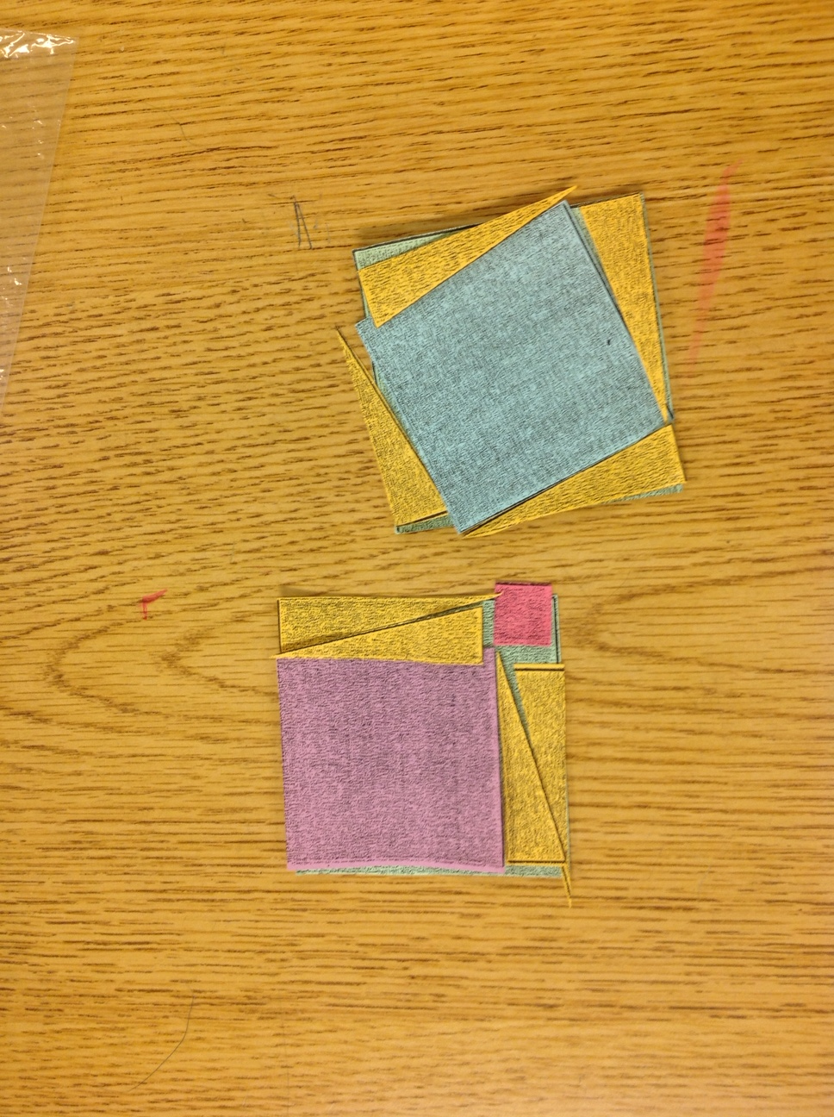
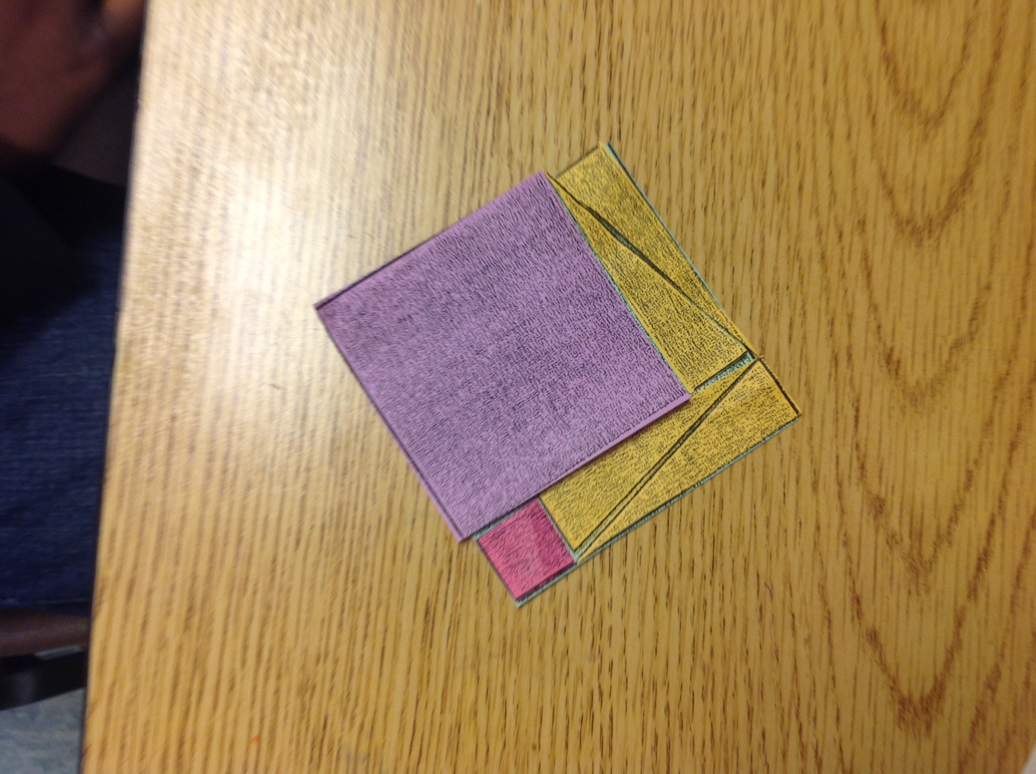

Student Misconceptions

Inability to Consider Slanting Blue Square

Purple/Blue Square Minimal Size Differential
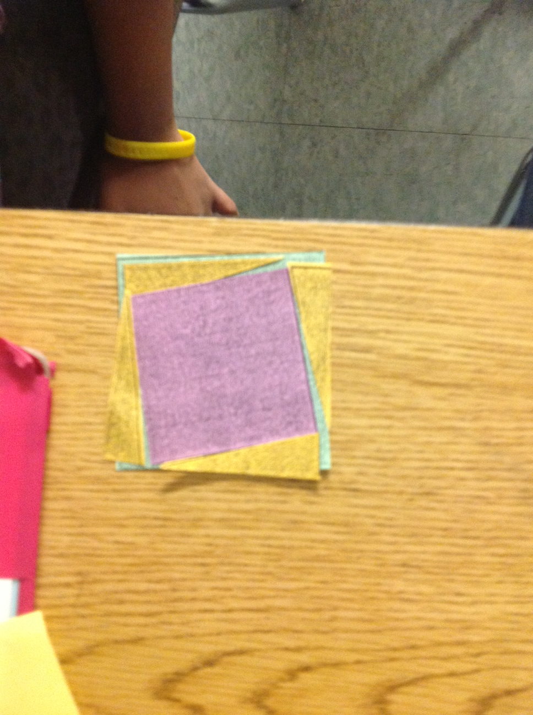

Entry/Exit Slip

